Practical 10 :- Asynchronous Processing with Event-Driven Architecture
Objective: | To implement asynchronous background processing using Node.js native EventEmitter without external dependencies.
Problem Statement: | • Add a background notification system to the Task Management application using Node.js built-in EventEmitter.  • When a new task is created via the API, emit a task-created event handled asynchronously.  • The event handler must log a notification (task title, timestamp, assigned user) without blocking the main response.  • The main API response must return immediately, before the event handler finishes executing.  • Demonstrate the difference between synchronous and asynchronous handling by logging timestamps at both the API response point and the  event handler execution point.
Implementation | Tasklistener.js  import taskEvents from './taskEvents.js';  /**  * Background Event Listeners.  *  * Registered once at application startup. Handles asynchronous, non-blocking  * side effects triggered by Task lifecycle events.  */  // Listener 1: Task Created -> Async Notification & Email Dispatch  taskEvents.on('task-created', (task) => {  const handlerStartTime = new Date().toISOString();  console.log(`[Event:Received] 'task-created' event caught at ${handlerStartTime}`);  // Supplementary Problem 3: Simulate heavy background notification (e.g. SMTP / Webhook)  // Using setTimeout proves non-blocking execution while the API response has already returned.  setTimeout(() => {  const completionTime = new Date().toISOString();  console.log('---------------------------------------------------------');  console.log(`[Notification Service] Email dispatched to: ${task.user || 'Workspace Member'}`);  console.log(`[Notification Details] Task: "${task.title}" (Priority: ${task.priority || 'medium'})`);  console.log(`[Notification Time] Completed at: ${completionTime}`);  console.log('---------------------------------------------------------');  }, 1500); // 1.5 second artificial delay simulating third-party email API  });  // Listener 2 (Supplementary Problem 1): Task Deleted -> Audit Log Record  taskEvents.on('task-deleted', (data) => {  const timestamp = new Date().toISOString();  console.log('---------------------------------------------------------');  console.log(`[Audit Trail] Task ID "${data.id}" permanently deleted`);  console.log(`[Audit Action] Triggered by: ${data.user || 'Authenticated User'}`);  console.log(`[Audit Time] Logged at: ${timestamp}`);  console.log('---------------------------------------------------------');  });  // Listener 3 (Supplementary Problem 2): Error Listener  // Catches and logs errors thrown inside event handlers, preventing Node process crashes.  taskEvents.on('error', (err) => {  console.error('[EventEmitter:Error] Unhandled error in background listener:', err.message);  });  console.log('[EventEmitter] Background task listeners successfully registered');  Taskevents.js  import { EventEmitter } from 'events';  /**  * TaskEvents — Application-wide Event Bus.  *  * Uses Node.js native EventEmitter without external message brokers.  * Decouples resource mutation (API response) from downstream side-effects  * (email notifications, audit logging, analytics indexing).  */  class TaskEventEmitter extends EventEmitter {  constructor() {  super();  // Default max listeners threshold  this.setMaxListeners(20);  }  }  export const taskEvents = new TaskEventEmitter();  export default taskEvents;  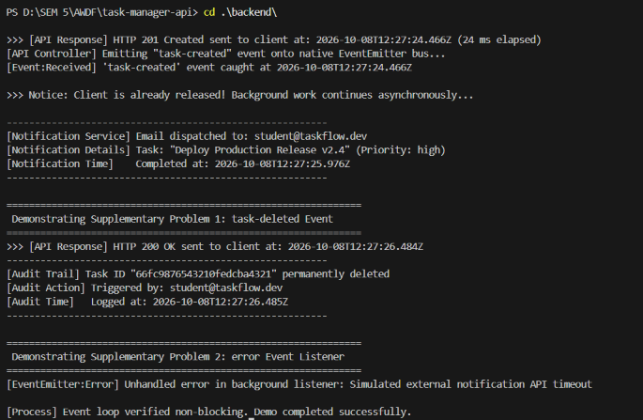
Outcome | Students will be able to implement non-blocking, event-driven background processing using Node's built-in EventEmitter and explain how it keeps the main request-response cycle fast.

